Exercise No:2 of Numpy

Q.1 a = np.array([0, 1, 2, 3, 4, 5, 6, 7, 8, 9])
print(a[2:5])

Q.2 b = np.array([[0, 1, 2], [3, 4, 5], [6, 7, 8], [9, 10, 11]])
print(b[:2, :2])

Q.3 array1 = np.array([[1, 3, 5, 7],
[9, 11, 13, 15]])
print(array1[:2, :2])

Q.4 array1 = np.array([[1, 3, 5, 7],
[9, 11, 13, 15],
[2, 4, 6, 8]])
subarray1 = array1[:2, :2]
Print(subarray1)

Q.5 array1 = np.array([[1, 3, 5, 7],
[9, 11, 13, 15],
[2, 4, 6, 8]])
subarray2 = array1[1:3, 2:4]
Print(subarray2)

Q.6 Create a 4×4 array and extract its first row and last column
Array:
[[ 1 2 3 4]
[ 5 6 7 8]
[ 9 10 11 12]
[13 14 15 16]]
First Row: [1 2 3 4]
Last Column: [ 4 8 12 16]

Q.7 Write a code to Create a 4×4 NumPy array and extract the first two rows and first two columns.

Array:
[[ 1 2 3 4]
[ 5 6 7 8]
[ 9 10 11 12]
[13 14 15 16]]
First 2 rows and columns:
[[1 2]
[5 6]]

Q.8 Get the positions where elements of array a and b match
Given:

a = np.array([1, 2, 3, 4, 5])
b = np.array([1, 4, 3, 7, 8])

Q.9

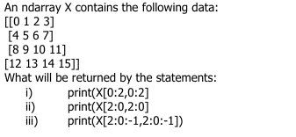

Q.10

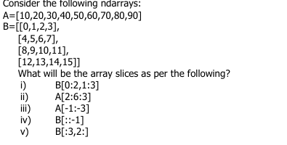

Q.11Write a program to convert 1D array into 2D array with 3 rows.
X=np.array([1,2,3,4,5,6,7,8,9,10,11,12])

Q.12

